# Question 03

## Code

clc

clear all

r=0.9;

t=10;

p0=100;

x=r*t;

p=(p0*exp(x))

## Output

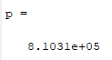

# Question 09

## Code

clc

clear all

p1=primes(20000);

p2=primes(10000);

np=length(p1) - length(p2)

## Output

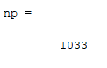

# Question 13

## Code

clc

clear all

d=120;

o=[30+3 30-3];

deg=o*pi/180;

h1=d*tan(deg)

## Output

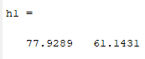

# Question 14

## Code

clc

clear all

% a

h=200;

d=20;

part_a=atand(h/d)

% b

part_b=sqrt(h^2+ d^2)

% c

h=h-6;

part_c=atand(h/d)

## Output

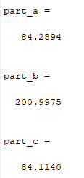

# Question 20

## Code

clc

clear all

% a

r=0;

r1=round(rand(1,1)*5+1)

% b

r2=round(rand(1,1)*5+ 1)

% c

r3=r+r1+r2

## Output

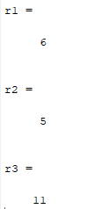

# Question 22

## Code

clc

clear all

zl=complex(0,5);

zc=complex(0,-15);

zr=complex(5,0);

zt=zl+zc+zr;

v=10;

i=v/zt

## Output

